**Forecast for The Cryptocurrency Market in 2024 and Onwards**

Reece A Singerle

**Abstract**

Comparing current trends and historical data points within the cryptocurrency market, it is clear a new bull cycle extending into the next year or more is forming. When Bitcoin moves up, the altcoin market follows and overtakes it, until eventually momentum dissipates and crypto slumps back into a bear market. Study of data from previous cycles, when combined with understanding several emerging trends peculiar to this cycle, gives the best insights for finding market inefficiencies and maximizing opportunity to profit.

This report first analyzes previous market cycles to identify recurring patterns and set metrics which will act as landmarks and allow the investor to orient themselves in the middle of the rapidly unfolding movements the crypto market is known for. Then it will identify several trends in the crypto space that differentiate this bull run from those past and highlight novel opportunities. Finally, it will bring these points together into a coherent strategy to best position the investor for exposure to the most promising narratives, manage risk to hedge more precarious positions, and plan market exits and contingencies.

**Disclaimer:** None of the information in this report constitutes professional financial advice and the report’s author is not a licensed financial advisor. Always seek the opinion of a qualified financial advisor before making any investments.

**Contents**

Analysis of Historic Trends During Bull Runs **5**

Anatomy of A Bull Run 7

Bitcoin Dominance and Altcoin Season 8

Altcoin Narratives in the 2021 Cycle 11

Emerging Trends in the Current Cycle16

ETF Approvals and Their Effects on Crypto 16

The Zeitgeist of Economic Uncertainty and “De-dollarizaion”17

Base Chain and Coinbase’s Master Plan 18

Tokenization of Real-World Assets 19

Meme Coins as a Medium for Betting on Social Trends 19

Telegram and the TON Chain 20

Putting it All Together – Investment Strategies **21**

Balancing High, Medium, and Low Levels of Risk 21

Investing in Identified Narratives 22

ETF Approval Narrative 22

Base Ecosystem Narrative 23

Tokenization Narrative 25

TON Chain Narrative 26

Exit Strategies and Deal-Breakers 27

Summary and Closing Thoughts **30**

References**31**

**Analysis of Historic Trends During Bull Runs**

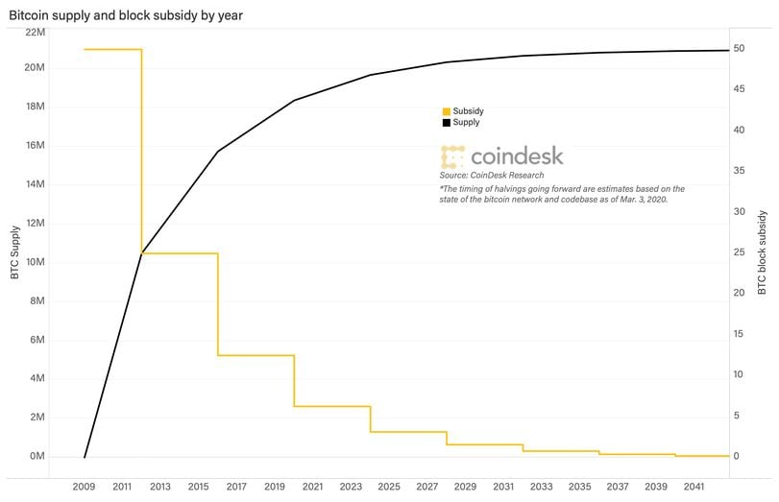 To understand the overall direction of the cryptocurrency market, it is necessary to understand Bitcoin, the oldest and most well-known, which has served to kickstart every cycle. Each Bitcoin bull run in the past has shared the same primary catalyst: an event known as the halving. In brief, mining rewards, which serve both as a mechanism of gradually releasing new coins into the market and as an incentivize for third parties to dedicate hardware for the maintenance of the blockchain, are on a baked-in downward trend. Every 210,000 blocks, which works out to roughly every 4 years, the per-block reward for mining is cut in half. Recently, the reward dropped from 6.25 BTC per block and to 3.125 BTC as of April 19th, 2024.

Figure 1: Bitcoin supply and block subsidy by year, courtesy of CoinDesk.com

The halving system is an elegant solution to two problems and introduces supply and demand mechanics which make Bitcoin uniquely cyclical. Bitcoin has a fixed supply of 21 million tokens, not all of which have been minted. As the sole minting mechanic, block rewards incentivize miners to dedicate their hardware (and the associated energy costs) to the network while distributing most of Bitcoin’s supply gradually. Miners receive block rewards constantly, which can immediately be sold on the market if they so choose. This means that, at least for now, Bitcoin is technically an inflationary currency. However, the halving mechanic uniquely introduces a staggered, diminishing rate of inflation, as illustrated by *figure 1*.

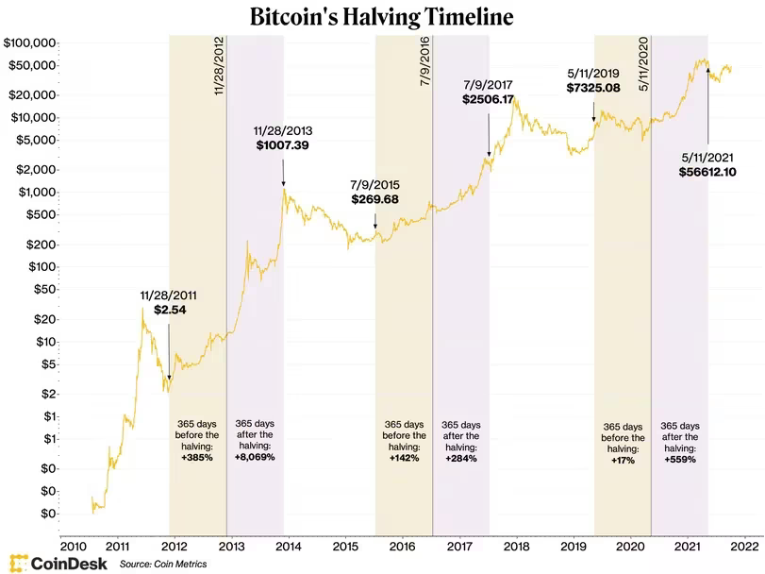Basic economic principles dictate that a supply which is, in effect, shrinking, paired with demand that is unchanged or increasing, should create upward pressure on price. This has always been the case with the halvings. Additionally, since the halving is predictable, the event is “priced in” by the market to some degree before it actually takes place as investors speculate on new highs. As expected, in both the year preceeding and following each of the three halving events so far, the price of Bitcoin has increased (Hertig).

While the cyclical price increases are dependable, the three halvings experienced so far have all produced gains of different degrees (*see* *figure 2)*. The first halving took place in November of 2012. Bitcoin’s low market cap of $128 million, combined with the lack of precedent for the event, primed the currency to rocket up to a 256% increase within 6 months, and a nearly 1000% increase within a year. 2016’s halving proved to be a slow climb compared to 2012’s violent leap. Initial returns were underwhelming, but a steady climb saw a new all-time high made at around $20,000 for a nearly 2500% increase by late 2017. Most recently, 2020’s halving produced a meteoric climb, aided by Covid-19 relief money flowing into the market and pushing a 700% increase (Jagielski).

Figure 2: Bitcoin price chart with pervious halvings marked by sold lines and 365-day periods preceding and following highlighted. Courtesy of CoinDesk.com

Anatomy of A Bull Run

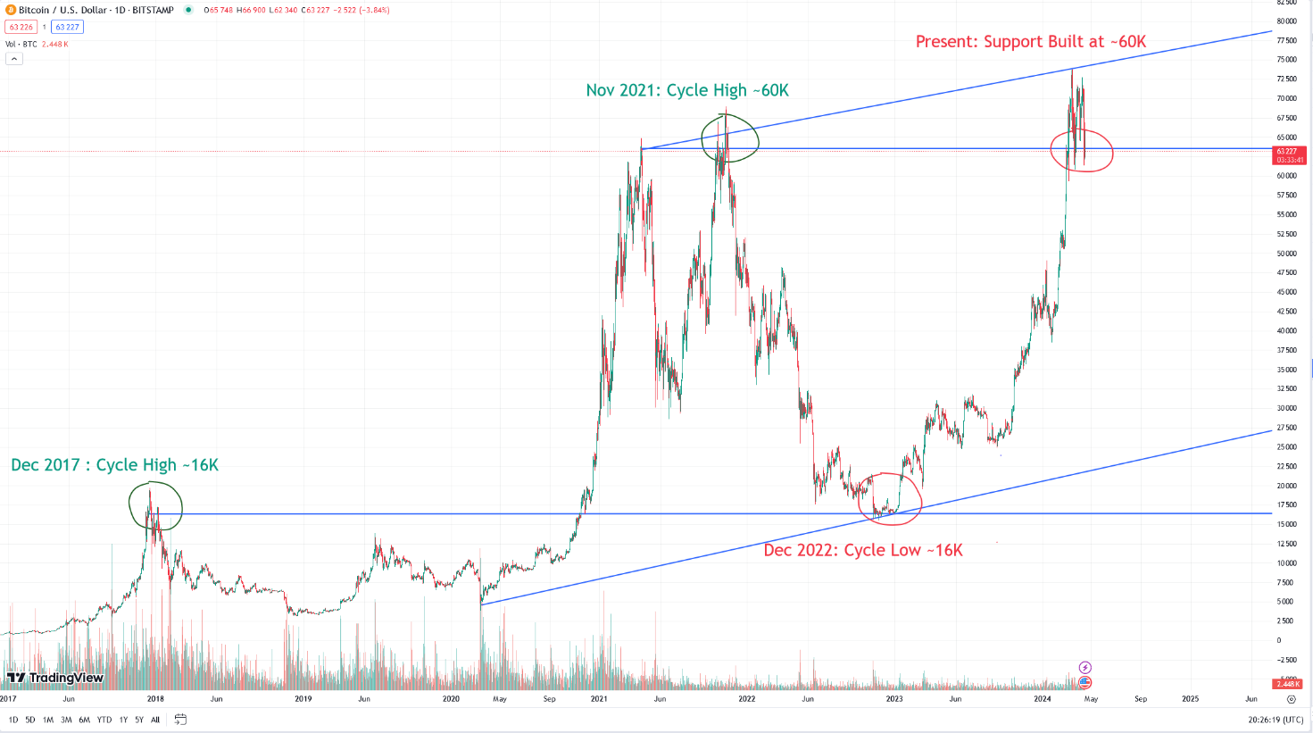 Taking the full picture into account, there is reason to be bullish on Bitcoin, and by extension cryptocurrency at large, outside of these short-term, halving-fueled price actions. A lifetime chart shows a steady uptrend for Bitcoin over the years, albeit with flared up volatility at certain times.

Figure 3: Price chart of bitcoin with all-time highs and cycle lows highlighted, plus lines of support and trend lines. Data courtesy of TradingView.com

Referring to *figure 3*, a long-term uptrend for Bitcoin is apparent. Interestingly, despite wild swings throughout the period from mid-2017 to now, new floors are established each market cycle at the previous cycle’s all-time high. Despite a dramatic freefall in 2022, for example, Bitcoin found unbroken support at around $16k, an all-time high reached five years ago in the previous bull run. Likewise, in spite of major pullbacks since January, 2024, Bitcoin has repeatedly tested and accepted support at around $60k. Another noteworthy observation from the lifetime chart: in the fifteen years that have passed since Bitcoin’s inception, there have been only two years where the all-time high or cycle bottom did not occur at the end of the calendar year.

Bitcoin Dominance and Altcoin Season

A key dynamic of the crypto market is the relationship between Bitcoin and altcoins. Where Bitcoin goes, the market tends to follow – for better or worse. In a bull market, top altcoins generally outperform Bitcoin’s gains. However, altcoins suffer the worst in a bear market, when investor sentiment shifts towards safety – their money either heading back into Bitcoin or out of crypto entirely and back into fiat currency. To paint a full picture, both the dynamics of money entering the market and moving between assets within the market must be understood.

To this end, Bitcoin dominance serves as a key indicator. This is a metric which tracks Bitcoin’s market cap as a percentage of the entire crypto market. A high Bitcoin dominance rating means lower market share for all altcoins and vice versa. Since Bitcoin is esteemed as the most well-established, secure cryptocurrency, higher Bitcoin dominance reflects conservative sentiment in the market (“Bitcoin Dominance”).

We often see high Bitcoin dominance at the beginning and end of a bull market. There are a few reasons for this. Firstly, Bitcoin is the entry point for most money in the market. It’s a household name at this point and always the first to make headlines as it rises and takes the limelight in the beginning stages. Additionally, Bitcoin’s popularity means it is almost invariably the first place that investors and retail traders new to the market park their money.

Towards the middle of the bull run, as Bitcoin’s price surges begin flattening out, money begins to flow from Bitcoin into “blue chip” altcoins, then to smaller coins, and finally into memes and highly risky assets. Once the top is reached near the end of a bull run, holders will eventually capitulate, either moving their capital from altcoins back into Bitcoin, withdrawing into fiat, or hold into the bear market.

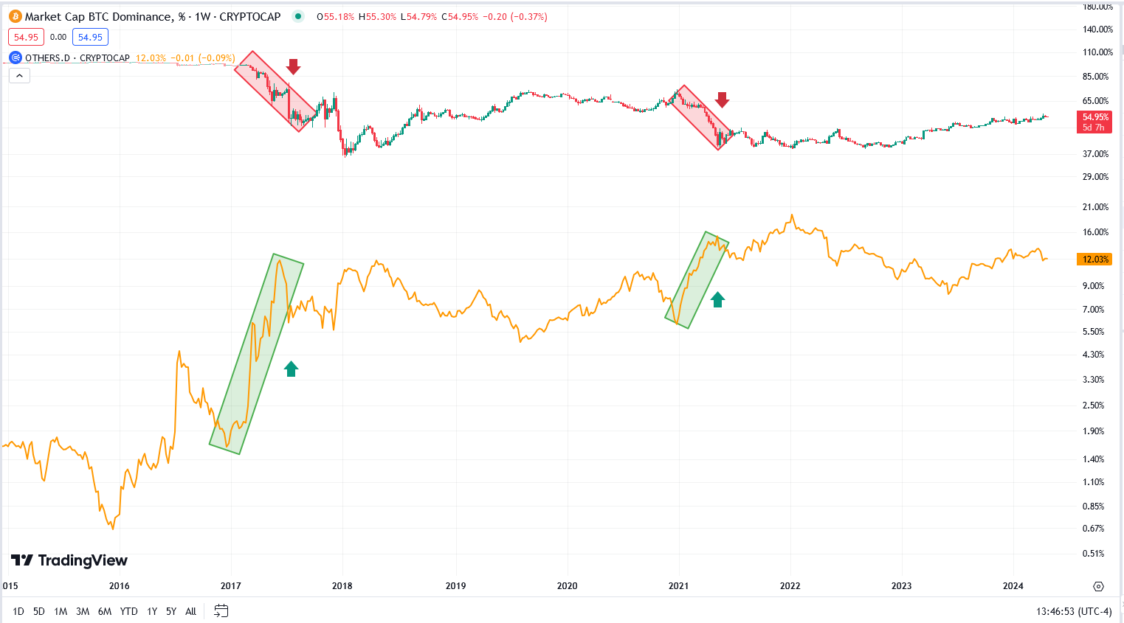 Figure 4: Bitcoin dominance (above, green and red candles) compared to the dominance of altcoins (below, orange line), excluding the top 10 by market cap. Data courtesy of TradingView.com

Looking at *figure 4*, we can see that the massive crypto rallies in 2017 and 2021 saw periods of rapid decline in Bitcoin dominance, with negatively correlated surges in altcoins’ collective market caps. While these surges are inevitably followed by pullbacks which signal the imminent end of the bull cycle, it can also be demonstrated that Bitcoin dominance has been trending downwards generally, while dominance of altcoins has risen.

*Figure 5* gives an insight into how prices move during these “altcoin seasons.” In the 2017 period, Bitcoin’s market cap saw an increase of nearly 670%, compared to nearly 4,000% for altcoins. In the 2021 market, Bitcoin’s increase of around 460% was again outshined by an 875% surge for altcoins. Additionally, in the decade of information portrayed in this chart, the ratio between bitcoin and altcoins’ market caps have closed the gap from 165:1 to less than 5:1, and even less during the highest peaks of 2021’s altcoin season.

This data enables us to draw several helpful conclusions. Firstly, Bitcoin is undisputedly the driver of the market, as evidenced by the very similar graphs between it and altcoins (which would be even more alike had the top 10 altcoins not been excluded). Secondly, altcoins are 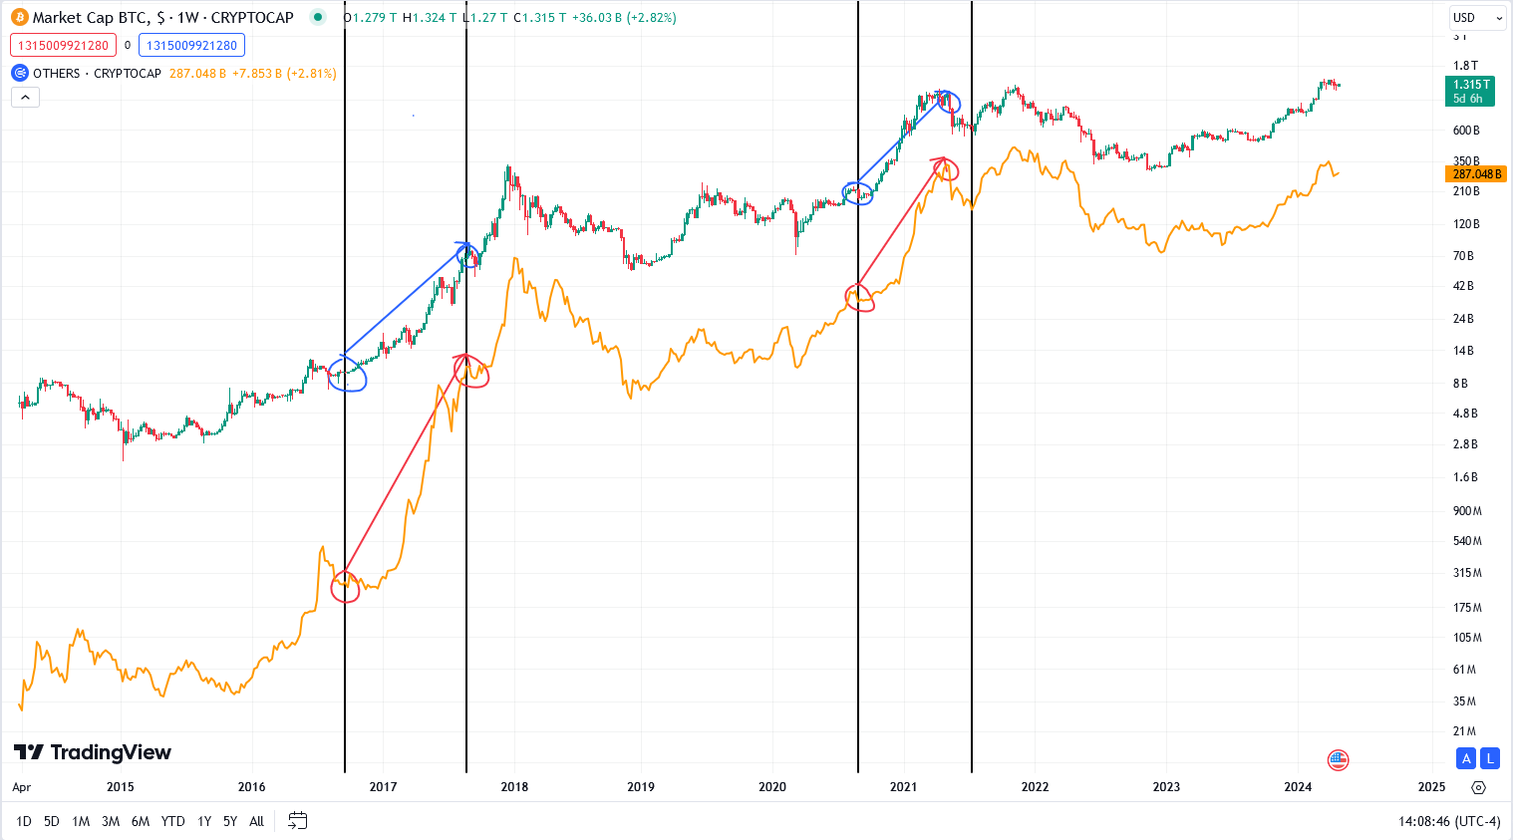trending upwards over time against Bitcoin and, if trends continue, could overtake it in terms of market cap and dominance within the next few years. Thirdly, and most importantly for the purposes of this report, altcoins rally during bull markets multiples more than Bitcoin.

Figure 5: Bitcoin market cap (above, green and red candles) compared to the total market cap of altcoins (below, orange line), excluding the top 10 by market cap. Periods enclosed by black lines correspond to highlighted periods of rapid decline of bitcoin dominance. Data courtesy of TradingView.com

One final metric to consider is Tether dominance. Tether (ticker USDT) is the most widely popular “stablecoin” linked (tethered) to the US Dollar. It is widely used by traders and investors as a safe haven to shelter from downward trends in the crypto market by holding US Dollars, while also being extremely easy to convert back and forth from traditional cryptocurrencies. In addition, Tether staking rewards make the asset even more attractive during bear markets, since its yields are guaranteed even in times when gains are hard-fought. As such, high Tether dominance is a bearish signal, while low Tether dominance is bullish.

*Figure 6* compares the trend lines between Tether dominance and the total cryptocurrency market cap; the negative correlation between the two is obvious. Essentially, periods where traders are accumulating Tether translate to selloffs of other cryptocurrencies, and a bearish sentiment towards the market as a whole.

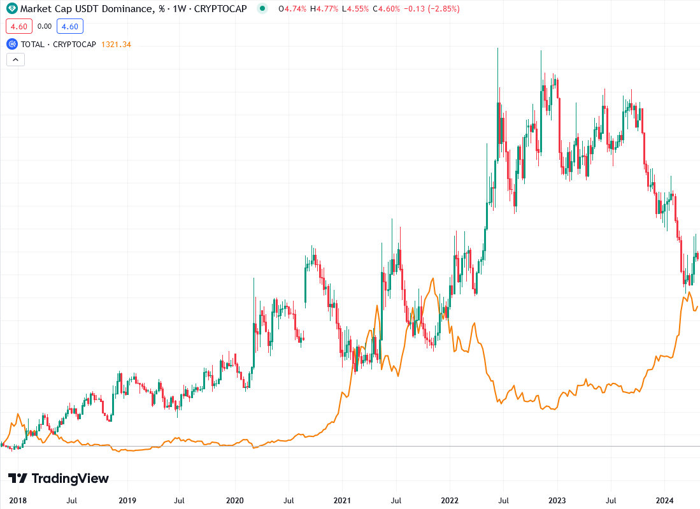

Figure 6: USDT dominance (green and red candles) vs total crypto market cap (orange line). Data courtesy of TradingView.com

Altcoin Narratives in the 2021 Cycle

The 2021-2022 bull run broke new ground for cryptocurrency. Along with reaching new all-time highs for the market as a whole, altcoins generally – and particular subsets of altcoins specifically – saw the greatest rallies by far. This was the cycle of new highs for meme coins and layer one projects trying to dethrone Ethereum, and of massive hype around metaverse and AI technology. Analyzing the specific narratives which propelled altcoins into the stratosphere last cycle helps contextualize what exactly can be expected in the current one.

The previous crypto cycle included a uniquely competitive atmosphere like none before it. With altcoins reaching new highs and more and more complex projects requiring smart contracts, several networks attempted to capitalize on perceived gaps in the market by rolling out their own smart contract blockchains.

Ether is firmly ranked as the #2 cryptocurrency, being the token of the #1 smart contract blockchain, Ethereum. While Ethereum enjoys a first-mover advantage, widespread adoption, and general trust from users, it has its shortcomings. Most notably, during periods of high traffic, the Ethereum network has a history of buckling under the congestion – sending gas fees and transaction times soaring. While Ethereum has been steadily making progress towards mitigating these shortcomings for years, several other projects have offered alternative networks, referred to as Layer 1 solutions.

Each boasting advantages over Ethereum in terms of speed, security, cheap gas, sustainability, privacy, exchange integration, or a number of others, Layer 1s saw their peaks in the 2021/2022 cycle. Out of the many contenders, BNB, Solana, Cardano, Avalanche, and Polkadot have cemented themselves as the top alternatives to Ethereum.

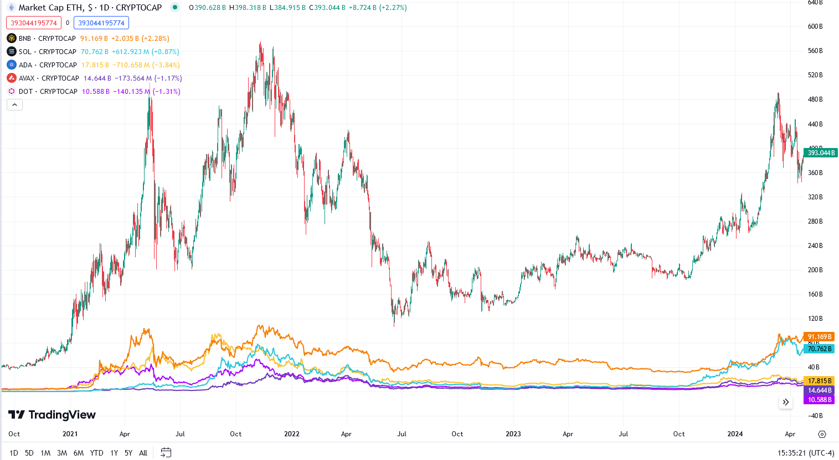

Figure 7: Market caps of alternate layer 1 solutions (BNB, SOL, ADA, AVAX, DOT) compared to Ethereum (green and red candles). Data courtesy of TradingView.com

As more capital, investors, and projects entered the market during the 2021-2022 bull run, Ethereum network strained under the increased traffic once again, pushing traders and developers alike to turn more and more to alternatives which were faster and cheaper. Solana in particular has been popular so far in the early stages of this bull run, though BNB has held onto the #2 spot thanks to its integration with the popular exchange Binance.

Memecoins like Dogecoin and Shiba Inu are the mascots of the 2021 cycle, being the most popular narratives with the general public and seeing the biggest gains in the market for the cycle. The concept of a meme coin can be baffling for a traditional investor. Meme coins generally offer none of the intrinsic value expected from typical cryptocurrencies in the form of a utility or promising technology. Instead, meme coins seek to capitalize on the mania surrounding memetic trends and altcoin season to produce a huge influx of capital and the resulting massive gains.

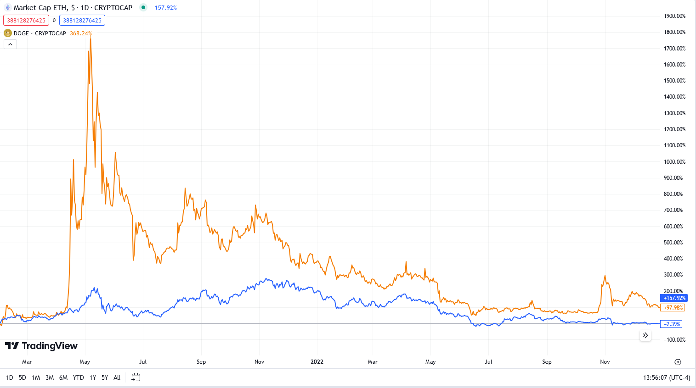 The meme coin market is almost a zero-sum gain. The vast majority of meme coins on any given chain fail totally and end up worthless, but a lucky few see rapid and astonishing gains unlike any other investment class on the market. The factors that separate the winners from the losers are virality, popularity of the underlying blockchain, and hitting “critical mass” – that is, gaining broad appeal and making headway into popular culture such that price snowballs into extraordinary gains.

Figure 8: Dogecoin (orange line) vs Ether (blue line) market cap percentage increases since Feb 01, 2021. Data courtesy of TradingView.com.

Meme coins can almost be considered a leveraged bet on the blockchain they’re deployed on. This is because the top meme coin on a given chain will absorb a considerable percentage of that chain’s market share. Take Dogecoin, the top meme coin on the Ethereum chain for 2021. Referring to *figure 8*, though it has a much smaller absolute market cap than Ethereum, Dogecoin rocketed up an astounding 1800% from February, 2021 to mid-May. Ethereum, at the same time, saw only a 250% increase during its cycle peak.

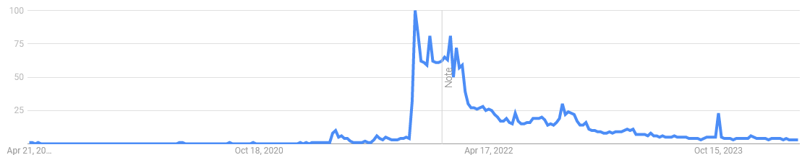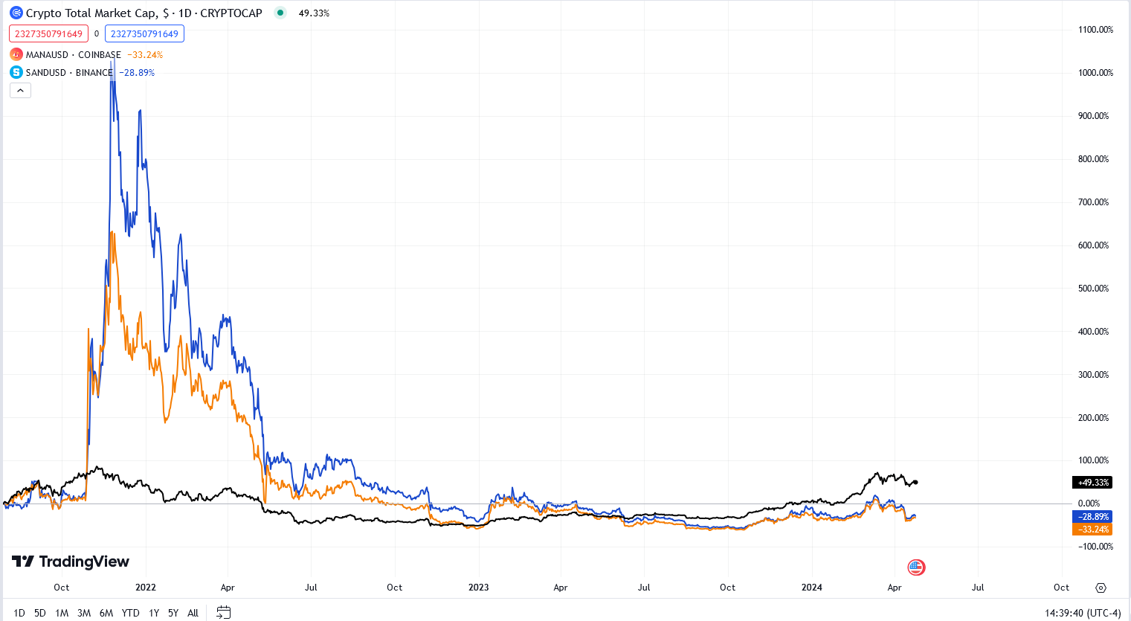While the two were intrinsically linked, Dogecoin, being an ERC-20 token on Ethereum’s blockchain, far outshined Ethereum under the same market conditions. At its peak, Dogecoin saw a market cap 1/5th the size of Ethereum’s at the beginning of May, 2021. Similar, albeit diminished, results are true of the runner-up Memecoins, namely Shiba Inu. As other chains gain traction and popularity, it’s very likely that the top memes on these will see incredible run-ups from new money flowing in as investors seek to maximize their bets on said chains.

Figure 9: Above: Graph comparing total crypto market cap growth (black line) with MANA (orange line) and SAND (blue line) since September, 2022. Below: Google search trends graph for the term “Metaverse.” Data courtesy of TradingView.com and Google Trends.

Somewhere between the utility-based proposition of Layer 1 solutions and the hype-oriented Memecoins, tech projects seeking to capitalize on the trending narratives of the time, the metaverse and web 3.0, also enjoyed massive success during the previous altcoin season. Top projects promised to deliver utility and fit into the anticipated digital goldrush that would be the metaverse (though, these dreams have petered out for now). Namely, Decentraland (ticker MANA), which saw run-ups from under 10 cents to over 5 dollars, and The Sandbox (ticker SAND), which launched from 60 cents to nearly 9 dollars in the metaverse craze of 2022.

Figure 9 demonstrates that, while altcoins like these can consistently beat the crypto market as a whole when their narratives are hottest, they face steep declines with a possibility of never recovering if their narratives cool down in favor of new ones. While Web 3.0 is generally still a popular narrative, with several related coins cementing themselves within the top 20 cryptocurrencies, other narratives like the Metaverse have fallen by the wayside. Predicting hot narratives has previously performed well, but it’s also vital to identify whether a narrative has staying power within both the markets and public square to avoid the plummets that leave a bygone coin underperforming the market altogether.

**Emerging Trends in the Current Cycle**

Cryptocurrency does not exist in a vacuum. Increasingly, as traditional finance and markets are integrated through mainstream crypto adoption, crypto is more beholden to narratives coming from governments, media, and institutional investors, in addition to its own. Understanding these narratives and how they will fit into the bull cycle are key for unlocking the full potential of the market.

ETF Approvals and Their Effects on Crypto

After years of speculation and months of anticipation, the SEC finally approved Bitcoin ETFs in January 2024. This has been the catalyst for the unprecedented setting of an all-time-high before the halving in this cycle, as speculative investors drove the price up and were followed by inflows of ETF money (Yerushalmy). The longer-term implications of ETF approval span far beyond rapid price action, however.

The most important function that ETFs are likely to serve is as a sort of bridge for traditional investment infrastructure, and the money it commands, into the Bitcoin market. This marks a new era for cryptocurrency – ETFs have historically increased price transparency to underlying assets and provided a new avenue of liquidity (“Bitcoin ETFs”). While these will, to some degree, lower Bitcoin’s volatility and reduce the potency of gains like those seen in previous cycles, this is a necessary step in market maturity needed to attract confidence and confer legitimacy from traditional investors and markets - which have thus far looked on cryptocurrency skeptically.

Of course, approval in the United States of a Bitcoin ETF raises the question of future ETF approvals. An obvious candidate is the number two cryptocurrency, Ether. While proposals are on the books already, there is a general consensus that the Ethereum ETF will not be approved by the upcoming deadline in May. However, there is still a real possibility to the contrary, and an even stronger case for its *eventual* approval (Morton and Lawant). An Ethereum ETF was also just recently approved alongside Bitcoin for the Hong Kong market (citation needed).

Overall, momentum is certainly in favor of traditional finance making inroads towards crypto. It is likely that an Ethereum ETF will see approval in the US eventually, and firms like Grayscale are pushing the envelope for the adoption of several other well-established altcoins, like Bitcoin Cash and Litecoin. We can expect these developments to drive prices up as new lines of liquidity open while limiting market volatility into the future.

The Zeitgeist of Economic Uncertainty and “De-dollarization”

Presently, in the United States, public sentiments have shifted in a very pessimistic direction with regards to the economy over the past few years. Since the Covid-19 pandemic, persistently higher prices of everyday consumer goods and housing, stagnated wages, inflation, and inflation expectations which are still too low among consumers have all contributed to a generally negative outlook on the economic future of the United States (Schneider). Such feelings are likely to spur investors, particularly those among the financially insecure youth, to find assets like cryptocurrency more attractive.

In addition, the general long-term decline of hard and soft power projected from the United States has put the dollar in a weaker position than ever. Following the unprecedented weaponization of sanctions against Russia by the West following the former’s invasion of Ukraine in 2022, a new narrative of de-dollarization has been developing in countries unfriendly to the old economic system (“BRICS Rebellion”). With BRICS representing a real effort to de-dollarize major world and regional powers in Asia, the Middle East, South America, and Eastern Europe, confidence in the Dollar is likely to continue diminishing in the near future.

Cryptocurrency, and specifically Bitcoin, fits nicely into this narrative, being a digital (and thus international) currency outside of the direct control of any government. Already, El Salvador has famously adopted Bitcoin as a currency (Lopez and Livni) and Venezuela has reportedly begun to use cryptocurrencies to bypass US sanctions on its oil trade (Brown). As the US continues to use sanctions and economic pressure as their primary means of soft power in the global community, their rivals will continue to pioneer ways outside of this system, for which cryptocurrency is an obvious choice.

It’s difficult to say whether cryptocurrency’s relationship to the dollar and traditional markets will do more harm or good for it. On the one hand, it is plausible that more countries will adopt Bitcoin to some degree as de-dollarization continues. At the same time, the more that cryptocurrency is exposed to traditional finance, the more susceptible it is to market movements in the US and EU, which will no doubt be negatively affected by de-dollarization.

Base Chain and Coinbase’s Master Plan

Coinbase is an established brand that is executing a strategy more forward-looking and totalizing than any of their competitors. The promise of their Base chain and its integration into a new frontier for cryptocurrency and finance promise huge rewards for investors who get in early and identify the projects most likely to succeed.

Coinbase was established in 2012 as one of the early cryptocurrency exchanges. It has enjoyed success and adoption from a large userbase, particularly in the US market. They reached a peak annual revenue in 2021 of $7.8 Billion, have a userbase of over 100 million, and controlled $223 Billion in assets under management in 2021 (Curry).

*The Coinbase Secret Master Plan* is a 2016 article which lays out founder Brian Armstrong’s vision for his company’s future in the crypto ecosystem (Armstrong). He articulates his vision for the future financial system by comparing it to the internet – open and decentralized, and arriving in four phases: protocol, infrastructure, consumer interface, and decentralized apps. Whereas for the internet, phases three and four where the advent of the browser and Web 2.0 services like Google, Amazon, and Facebook, Armstrong predicts highly integrated, user-controlled wallets and “Finance 2.0” will be the corresponding breakthroughs for crypto. Coinbase has already brought phases two and three into fruition with their popular exchange platform and wallet.

BASE chain, a new layer 2 solution built on Ethereum provides a promising platform for phase four. Coinbase has been actively involved with sponsoring and cultivating several third-party projects aiming to bring the plan to fruition on Base. From projects like Aerodrome, which seeks to create a competitor to decentralized exchanges like Uniswap and Pancakeswap to Truflation, which tokenizes real assets in order to provide transparent data on trends like inflation and cost of living, Coinbase has put their money where their mouth is and are cultivating a holistic ecosystem on their own platform.

Having laid it all out in the *Master Plan,* there’s good reason to be bullish on Coinbase’s project. Their history of development, generous sponsorship of great projects, and large userbase ready to be onboarded are all great signs for Base’s future. Beyond that, Coinbase has laid the track up until now for new money to enter the markets – from their exchange where users can immediately transfer funds from their bank account, to their stablecoin USDC, to the Coinbase Wallet and eventually the wider Base network, this is one of the most compelling narratives of this cycle by far.

Tokenization of Real-World Assets

Tokenization of real-world assets (RWA’s) is the process of onboarding a physical asset by creating an on-chain digital representation of it. This shares the obvious advantages of a physical security –being quickly transmittable and tradable without transporting or taking delivery of the underlying goods – but iterates with the advantages of increased transparency, security, speed, international access, and low fees provided by blockchain technology.

Blackrock CEO Larry Fink said in an interview that the next generation for markets will be the tokenization of assets (McCurdy). With such an unequivocal statement from the manager of one of the world’s largest hedge funds, there is good reason to be optimistic about this emerging narrative. Though still an unproven concept, project Flowcarbon, which seeks to tokenize carbon credits, managed to raise $70 Million in investor capital from big names like Samsung Venture Investment and General Catalyst (McCurdy). Truflation, another RWA project that seeks to use the transparency of the blockchain to provide accurate economic data untouched by censors, has attracted lots of general interest, being covered by Bloomberg, The New York Times, and others, along with backing from Coinbase itself. Overall, RWAs are a sensible next step for cryptocurrency and the most obvious use-case of the technology for traditional finance.

Meme Coins as a Medium for Betting on Social Trends

Online gambling has seen a meteoric rise in the United States since a precedent-setting Supreme Court Ruling in 2018. The ruling, which deemed the 1992 PASPA act invalid, leaves states free to determine for themselves whether they will permit sports gambling. Since then, 26 states have legalized online sports gambling, and 4 more have passed similar bills which are not yet in effect (Bengel and McCarriston). Sportsbook apps including Fanduel, Draftkings, and BetMGM have all seen dramatic increases in sales from 2022-2023, specifically among a young, tech-savvy demographic (Jones). Such a crowd could easily rotate into the cryptocurrency market as a new medium for gambling – this demand may be filled perfectly by meme coins.

Meme coins’ rapid fluctuations are due to the fickle nature of their basis: social currency. These meme coins live or die on virality and attention; hype built on social media generates interest with a wide audience, which then drives capital into the coin and drives up the price (Veiga). As soon as the hype dies out, however, momentum is lost and the price stalls or, even worse, plummets as holders lose faith that it will ever regain its popularity.

Where these trends overlap is obvious – it stands to reason that a new bull run, with the mania it generates, could facilitate another meme coin rush funded by largely young, tech-savvy retail traders who have already proven they have a taste for gambling. Given that, presumably, many are engaging with sports betting for the convenience and accessibility of sportsbook apps rather than a particularly strong interest in the sports themselves, if they were made aware of a means to, in effect, gamble on the virality of their favorite memes, it’s easy to hypothesize a massive inflow of interest from this particular crowd. The likelihood of this outcome is significantly enhanced if the bull run takes off by Q3-Q4 of 2024 as the election draws nationwide interest and spurs massive political meme virality. This is certainly a higher-risk, shorter-term narrative than the others identified so far, but in turn stands to deliver the most dramatic gains if actualized.

Telegram and the TON Chain

A final narrative yet to really pick up steam is the rolling out of Telegram’s TON (The Open Network) chain. Telegram, a messaging app with 800 million users worldwide, dropped development of their own blockchain in 2020 following threats from the SEC, but the project has since been picked up by a loyal community and, despite remaining a separate entity from Telegram, has been endorsed and will be integrated by the company (Crawley). Telegram is developing a wallet built into the messaging app that is already live in many countries but currently excludes the United States. In addition to the bullish prospect of onboarding the majority of their userbase within the next few years, Telegram’s messaging platform is already particularly popular among cryptocurrency communities. Despite these favorable conditions, the chain is still relatively unknown and difficult to buy into for US traders, making it possible for investors willing to go out of their way to invest in the chain to front-run millions of future users.

**Putting it all Together – Investment Strategies**

Combining the data on previous bull runs and market dynamics from Chapter I with the emerging narratives detailed in Chapter II, investment principles to maximize a favorable risk-to-reward ratio become clear. In addition, estimates can be made for potential tops in the market based on available data, providing necessary metrics for exit strategies. Finally, parameters should be established to identify if trends have broken and postulates are no longer valid, meaning an early exit is necessary.

Balancing High, Medium, and Low Levels of Risk

As with any portfolio, investors must determine for themselves a tolerable level of risk and only open positions in accordance. To this end, a mix of high, medium and low risk investments lends itself well to the “tiers” of currencies established by the market. Generally, Bitcoin and Ethereum are in a league of their own, being seen as extremely likely to make gains in a bull run – albeit with limited upside compared to other options – and to not crash below previously established levels of support during bear markets. Next, in the medium-risk category, are “blue chip” altcoins. These are the top altcoins with market caps over $500 million, which are usually well-established, easy to trade instantly on popular exchanges, and featured prominently on them. Finally, microcap altcoins, including meme coins, are the riskiest investments on the market. With market caps under $500 million (often times significantly lower), the upside on these coins is massive if they reach “blue chip” level, though most never do.

While this paradigm is helpful to quickly categorize different investments, the real market doesn’t fit so neatly into it. The lines between high-cap and low-cap altcoins tend to be blurry, and the postulate established in Chapter I should be kept in mind: during a crash, the downside of most altcoins is the same, while the upside can be vastly different.

Accordingly, a portfolio should weight these categories unequally for the best results. The lowest risk coins – Bitcoin and Ethereum – should hedge positions in the riskiest – microcaps and Memecoins. Medium-risk coins should generally not make up a large portion of a portfolio except where, on a case-by-case basis, there is a special value proposition, given their equal downside and limited upside compared to higher-risk options. Of course, specifics are determined by the investor’s personal risk tolerance.

The method to determine risk ratios within a portfolio should be as follows. First, the investor should determine their outlook on the current market as a whole. Since the market largely follows Bitcoin, it is a logical place to start. Given previous returns after halvings (1000% in 2012, 2500% in 2016, 700% in 2020), and factoring in diminishing returns, a conservative estimate puts Bitcoin around $150,000 for a little over 115% gain from the April, 2024 halving. Therefore, a safe bet in this scenario would be to allocate half of the portfolio to Bitcoin, which will hedge a total loss of the other half’s capital in a mix of high-cap and low-cap altcoins.

With more bullish scenarios or a higher risk tolerance, optimal ratios change. For example, given that Ethereum tracks closely with Bitcoin, there is limited opportunity cost in holding it over Bitcoin. An investor who believes that the approval of an Ethereum ETF and a resulting price surge could allocate more of their low-risk funds to Ethereum, which would then hedge a bigger allocation in medium and high-risk positions than Bitcoin alone.

Investing in Identified Narratives

The next step in determining an investment strategy is finding the best avenues to speculate on the narratives previously identified and to determine where they fit in the risk allocation. It is also a matter of discretion for the individual investor to determine which narratives they are most confident in and allocate accordingly. It is best practice to invest in several leading projects in each narrative to increase odds of success - that is - to bet on narratives themselves, and not on individual projects they contain.

ETF Approval Narrative

To begin, ETF approvals present straightforward targets. It is simple to identify cryptocurrencies most likely to receive ETF approval, as presented earlier. The most obvious candidate is Ethereum, but there is more upside with a high chance of approval for Litecoin as well. As mentioned before, Grayscale and Blackrock are acquiring Litecoin and there are applications in progress with the SEC for it (citation needed).

From the approval of Bitcoin ETFs by the SEC on January 10th, 2024 to the new all-time high established on March 13th, Bitcoin’s market cap saw a 56% increase, equivalent to $515 billion. Obviously, not all of this can be attributed to inflows or speculation around ETFs – this period also closely led up to the halving. Nonetheless, Bitcoin ETFs saw net inflows of $12.1 Billion in Q1 2024 (Torpey, “Spot Bitcoin”), which certainly contributed to the gain itself, let alone the investor hype built by the historic approval.

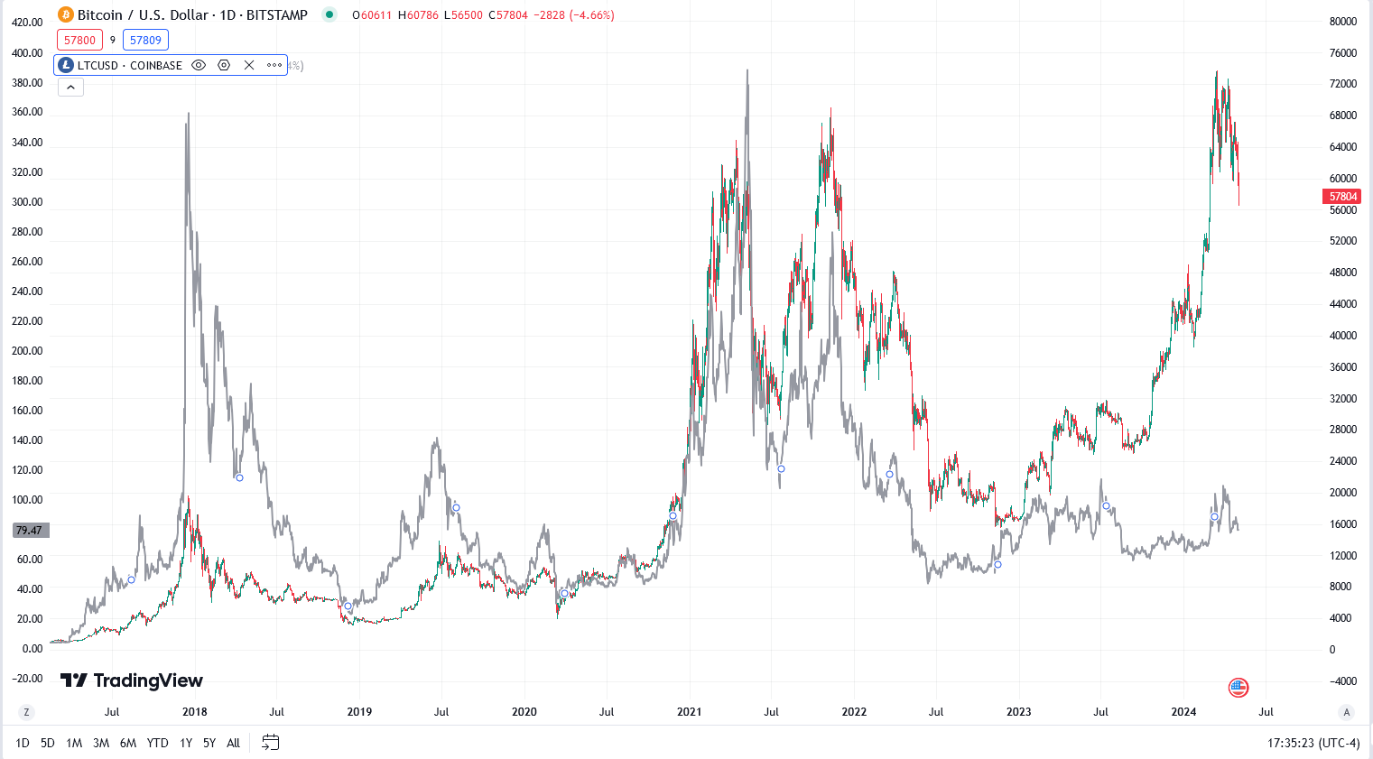While Ethereum or Litecoin ETFs would not generate as much interest as Bitcoin, more price impact would be felt for every dollar of liquidity coming in, owing to the two currencies’ lower market caps. Compare Bitcoin’s market cap of $914 billion on the day of the approval to Ethereum’s current $363 billion, or Litecoin’s relatively measly $6.2 billion and it becomes clear that even interest equivalent to a fraction of that in the Bitcoin ETF could have serious positive impact on price.

Figure 10: Bitcoin (green and red candles, price on right) compared to Litecoin (gray line, price on left) price in USD. Data courtesy of TradingView.com

Litecoin in particular seems to be undervalued given this information. Even disregarding the likely possibility of an ETF approval, Litecoin has historically tracked closely with Bitcoin, decoupling and falling behind only recently in Q1 2024, implying a catch-up is likely later in this cycle. Still, approval of a Litecoin ETF is very possible for a few reasons. The source code for Litecoin is essentially identical to Bitcoin’s, except that its supply is four times larger and its transaction speed is superior. Because of the nearly identical code, it seems unlikely that the SEC would deny a Litecoin ETF after approving one for Bitcoin. In addition, Litecoin’s higher token count, lower fees, and faster transaction speeds have made it increasingly popular as an online payment option (L, Paul). In a scenario where Litecoin ETFs attract even 2% of the liquidity Bitcoin ETFs did in their first quarter, it would propel Litecoin’s market cap up 39%. Out of the likely ETF approvals in the near future, Litecoin offers the best upside, followed by Ethereum.

Base Ecosystem Narrative

Base chain doesn’t have its own native currency, but there are a select number of projects which Coinbase has endorsed and will likely be the best-performing investments in the beginning stages of the platform. There are six projects invested into by the Coinbase Ventures’ Base Ecosystem Fund: Avantis, BSX, Onboard, OpenCover, Paragraph, and Truflation. The majority of these projects have not launched their own tokens yet, making it possible to scoop up tokens at IPO price in the near future. Truflation and BSX do have their own tokens, but both still have large upsides as Base is rolled out. Additionally, standout projects like Aerodrome, Aviator, and Rarible stand to fill specific needs in an emerging Base ecosystem as a decentralized exchange, bridge, and NFT marketplace respectively. There is already a myriad of projects under development for Base, but the surest bets are likely those endorsed by Coinbase directly and those with the highest market caps.

How much potential does Base chain have? Being a layer 2 solution, projections should begin with the underlying Ethereum chain. The market cap of the Ethereum network currently sits at $403 billion. Currently, the two most popular ETH L2’s are Arbitrum, at $187 billion, and Optimism, with $180 billion. These two are neck-and-neck, each with a market cap a little under half of Ethereum’s. The Base ecosystem currently sits at a total cap of $2.44 Billion. If Base were to gain a market share similar to Arbitrum or Optimism, that would entail a 75-fold gain. Already, Base has considerably more momentum than either of these chains at launch, reaching 1 million active wallet addresses on network a mere 11 days after release, compared to Arbitrum’s 303 days and Optimism’s 191 days needed to reach the same metric (Phong). More conservatively, Base rising to the level of moderately popular L2 Polygon, with its $36.6 billion market cap, would still entail a 15-fold gain for Base.

Moreover, as established previously, Coinbase intends to onboard their 100 million users to Base chain moving forward. With a current userbase sitting around 2 million (Phong), hitting this goal would mean an increase in users of 50 times – each bringing funds over to the chain. When factoring in Coinbase’s thousands of institutional customers and the billions of dollars in their accounts (Dean), it’s not hard to believe that the average value migrated over to the chain from just existing users could be in the hundreds or thousands of dollars each. Over the long term, it seems likely that if Base continues to meet with success, growth in the multiples is within grasp.

Tokenization Narrative

The winning move in the tokenization or real-world-asset narrative is to invest in projects which could catch the attention of traditional hedge funds and exchanges and build adequate infrastructure to become integrated into their markets. It’s likely that these institutions will not create the necessary infrastructure in-house, but will rather partner with teams that have experience and an already working product. Two standouts so far are Propy and Ondo Finance. Propy is a new project that seeks to tokenize deeds for real estate transactions, leveraging the advantages of non-fungibility, security, and traceability provided by blockchain technology. Ondo Finance is a project constructing on-chain infrastructure for interacting with traditional markets and financial institutions.

New organizations may offer better solutions in the future – that’s why it’s wise to invest in the narrative and not weigh too heavily towards individual projects. While upsides for the top projects will be huge, the scale of their potential is hard to quantify accurately in numbers until adoption and integration unfolds. However, the wealth commanded by traditional finance promises great returns for any project that gets picked up by it.

TON Chain Narrative

The TON chain is still very early in adoption and has many barriers to entry for US citizens. For this reason, there are not many coins or much value currently on TON, but this will change as Telegram onboards its international users and the TON Foundation seeks approval for US users. Holding the native TON coin itself is probably the safest investment which is directly correlated with the chain’s success. Alternatively, REDO, the top meme on the chain by far in terms of market cap and popularity, presents a riskier bet on the chain’s adoption; as established earlier, the top meme coins on a given chain in effect are leveraged bets on that chain’s success.

Telegram, the company which served as progenitor of the project, is a huge messaging and social media app experiencing rapid growth. It was the fastest growing app in 2022, gained 2.5 million new users daily in January 2023, and is already the fourth largest messaging app globally - its 800 million monthly active users eclipsing even X (formerly known as Twitter). Additionally, factors like the $1.2 million worth of Chinese exports sold through Telegram in 2020 and its market share of over 50% among internet users in Russia, Indonesia, Malaysia, Brazil, and India point to a promising opportunity for commerce to grow on Telegram (“A Deep Dive”).

The TON chain itself saw a 154% increase in daily active users from June to November 2023, now at around 810,000. With a current average growth rate of 1.5k new users per day, the TON Foundation has set an even more ambitious goal to onboard 500 million of Telegram’s users by 2028 (“A Deep Dive”).

With TON’s current active user count of around 810,000, keeping with the current steady growth rate would mean a more than tripling of this count by 2028, while TON’s ambitious goal of onboarding a significant portion of Telegram’s userbase would mean an increase of 617 times in the same period. Though, in terms of numbers, this is even more bullish for TON than Coinbase’s onboarding of its users is for Base, it should be noted that Telegram is not primarily a cryptocurrency platform like Coinbase and that most of its users are from less wealthy nations like Russia, India, and Brazil, as opposed to Coinbase’s largely American consumers.

Nonetheless, these figures help determine a ballpark estimate of TON’s potential. With a current market cap of $7 billion, assuming new users bring an average value of $100 on-chain, the lower-end estimate of just maintaining the current steady growth rate would mean an influx of $219 million by 2028, while meeting the foundation’s stated goal of 500 million users would see a cap over $60 billion in the same four years. Per their website, the TON team is also currently working on improving interoperability by creating bridges with traditional networks like Ethereum, BNB, and Bitcoin, which should see further inflows from speculators outside of the Telegram userbase as well.

It is certain that TON will experience growth in the coming years, and perhaps to an extreme degree if the TON Foundation and Telegram are able to roll out a successful integration. The safest bet to benefit from this growth is Toncoin itself, the network’s native currency which most new liquidity will enter from Telegram’s wallet and in which transaction fees are denominated, staking rewards are minted, and Telegram ads are purchased. Alternatively, the top meme coin on the chain, REDO, could serve as an effectual leveraged bet on the chain’s success – a phenomenon noted earlier.

Exit Strategies and Deal-Breakers

Just as important as having a strong set of convictions behind a portfolio is having an exit strategy and being able to identify when underlying theses have been disproven. Though specific exit points and proportions, like risk tolerance, need to be determined for the individual investor, there are objective metrics and conditions applicable to the strategies discussed in this report.

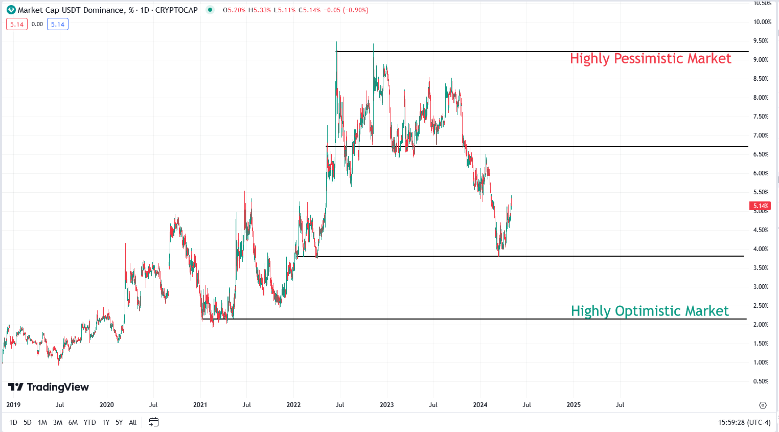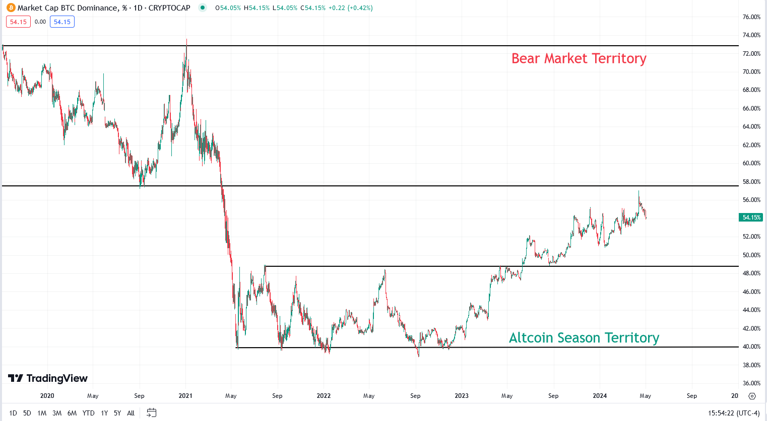As observed previously, two indispensable historical metrics for monitoring general sentiment in the crypto market are Bitcoin and Tether dominance.

Figure 12: Chart showing USD tether dominance, with key lines of resistance and support denoted. Data courtesy of TradingView.com

Figure 11: Chart showing bitcoin dominance, with key lines of resistance and support denoted. Data courtesy of TradingView.com

Breakthroughs past key resistances and supports in these charts (see figure 11) can help to identify reversals in the market and when traders are moving to front-run them. For example, an investor may want to begin shifting heavily into altcoins when Bitcoin dominance pushes below the support at 49% and back into Bitcoin or cash as it nears the support at 40%. In the case of Tether dominance, a break past support at 3.75% indicates strong buying pressure likely to go further, while piercing resistance at 6.75% signals that the top of the market is in and the reversal into a bear market is coming soon.

These overarching market sentiments are best supplemented by monitoring projections for individual narratives. For example, keeping in mind earlier projections of Base reaching the modest market share of Polygon (9% of Ethereum) or reaching levels comparable to Arbitrum and Optimism (50% of Ethereum), the ratio of Base’s market share to Ethereum’s is a more useful metric than its dollar amount, since Ethereum is driven heavily by larger market forces. Therefore, an investor may begin to take profits at a 1:10 ratio of Base to Ethereum market cap with an upmost target of 1:2, all the while watching to make sure that Bitcoin and Tether dominance don’t suggest a negative outlook on the whole market.

Not all sell signals can be quantified with numbers. Some are obvious – a headline or press release saying that Blackrock will never partner with an RWA project, for example. Others can be more subtle – an increase of ads for crypto exchanges on television, a coin trending on X (formerly Twitter), or even overheard conversations of regular people discussing crypto in day-to-day life. These anecdotes should not be the basis of an exit strategy, but investors should bear them in mind when sentiment is hard to pinpoint by data alone. Ultimately, a good exit strategy is multifaceted, unshakable by market movements as long as core convictions remain unchanged, and vigilantly waiting for a confluence of several top signals coming together.

**Summary and Closing Thoughts**

The cryptocurrency scene is turbulent, volatile, and maniacal to a degree head-and-shoulders above traditional markets, owing to its relative youth and unique potential. To the benefit of the wise investor, this new frontier presents market inefficiencies ripe for exploitation in the relative absence of hedge funds and regulators with hands in the pot.

Despite this novelty, the past four cycles have presented clearly distinguishable patterns that serve as the basis of a sound strategy: accumulation of Bitcoin in the bear market, transition into alternatives during altcoin season, and withdrawal back into cash or Bitcoin at the end of the bull market. Using this understanding as an outline, diligent investors can work with a huge advantage over retail traders motivated by “FOMO” who lack a larger picture or thesis.

A further grasp of the inner workings and technology of the cryptocurrency ecosystem, as well as the motivations and plans of prime movers like Coinbase and Blackrock, opens up even greater opportunities to seize upon narratives before they become popular and to profit off of an early arrival.

Finally, strong convictions based on a solid thesis advantage the informed investor by giving them the reassurance to hold through lulls and downturns and to sell in spite of widespread greed and mania at the peak of the market. This report has sought to educate the reader and arm them with all of these tools necessary to succeed in the coming cycle. However, it is up to the individual investor to determine their own risk tolerance and their own degree of faith in the narratives laid out herein, and to monitor the market with a commitment to a clearly defined strategy for every step of the way. *Blessed are the humble, for they will inherit the earth.*

**References**

Armstrong, Brian. “The COINBASE Secret Master Plan.” *Coinbase Blog*, Coinbase, 7 Sept. 2016, www.coinbase.com/blog/the-coinbase-secret-master-plan.

Bengel, Chris, and Shanna McCarriston. “U.S. Sports Betting: Here Is Where All 50 States Currently Stand on Legalizing Online Sports Betting Sites.” *CBS Sports*, CBS, 17 Nov. 2023, www.cbssports.com/general/news/u-s-sports-betting-here-is-where-all-50-states-currently-stand-on-legalizing-online-sports-betting-sites/.

“Bitcoin Dominance: What Is BTC.D and How Does It Impact the Crypto Market.” *WhiteBIT Blog*, WhiteBIT Blog, 11 Apr. 2024, blog.whitebit.com/en/what-is-bitcoin-dominance-btc-d/.

“Bitcoin Etfs: Navigating the New Frontier with Ishares: Ishares.” *iShares*, Blackrock, 2024, www.ishares.com/us/about-etfs/bitcoin-etfs-a-new-era-of-access.

“Brics Rebellion: Plotting the End of Dollar Dominance and U.S. Economic Power | Seeking Alpha.” *Seeking Alpha*, Equity Management Academy, 8 Apr. 2024, seekingalpha.com/article/4682637-brics-rebellion-plotting-the-end-of-dollar-dominance-and-us-economic-power.

Brown, Collin. “Breaking: Venezuela Switches from USD to Bitcoin and Tether (USDT) for Oil Sales, Evading US Sanctions.” *Crypto News Flash*, 26 Apr. 2024, www.crypto-news-flash.com/breaking-venezuela-switches-from-usd-to-bitcoin-and-tether-usdt-for-oil-sales-evading-us-sanctions/.

Crawley, Jamie. “Messaging App Telegram Gives Endorsement to Ton Project; Token Surges.” *CoinDesk Latest Headlines RSS*, CoinDesk, 13 Sept. 2023, www.coindesk.com/business/2023/09/13/messaging-app-telegram-gives-endorsement-to-ton-project-token-surges/.

Curry, David. “Coinbase Revenue and Usage Statistics (2024).” *Business of Apps*, 17 Apr. 2024, www.businessofapps.com/data/coinbase-statistics/.

Dean, Brian. “Coinbase Usage and Trading Statistics (2023).” *Backlinko*, 21 Aug. 2023, backlinko.com/coinbase-users.

“A Deep Dive into the Ton (The Open Network) Ecosystem.” *Medium*, OKX Ventures, 27 Nov. 2023, okxventures.medium.com/a-deep-dive-into-the-ton-the-open-network-ecosystem-34376fdd6082.

Hertig, Alyssa. “Bitcoin Halving, Explained.” *CoinDesk*, CoinDesk, 16 Apr. 2024, www.coindesk.com/learn/bitcoin-halving-explained/.

Jagielski, David. “History Says This Is What Happens after Bitcoin Halving.” *The Motley Fool*, The Motley Fool, 9 Apr. 2024, www.fool.com/investing/2024/04/09/history-says-this-is-what-happens-after-bitcoin-ha/.

Jones, Callum. “‘We’re Killing the Youth of America’: Calls Grow for Crackdown on US Gambling.” *The Guardian*, Guardian News and Media, 1 Dec. 2023, www.theguardian.com/us-news/2023/dec/01/sports-betting-regulation-gambling-addiction.

Kuznetsov, Nikolai. “A Little Bit of History Repeating? The Numbers behind Bitcoin’s Bull Run.” *Cointelegraph*, Cointelegraph, 17 Mar. 2021, cointelegraph.com/news/a-little-bit-of-history-repeating-the-numbers-behind-bitcoin-s-bull-run.

L., Paul. “Litecoin Ranks among Most Popular Cryptocurrencies for Online Shopping in 2022 - Coingate Report.” *Finbold*, 1 Mar. 2023, finbold.com/litecoin-ranks-among-most-popular-cryptocurrencies-for-online-shopping-in-2022-coingate-report/.

Lopez, Oscar, and Ephrat Livni. “In Global First, El Salvador Adopts Bitcoin as Currency.” *The New York Times*, The New York Times, 7 Sept. 2021, www.nytimes.com/2021/09/07/world/americas/el-salvador-bitcoin.html.

McCurdy, Will. “Blackrock CEO Says ‘next Generation for Markets’ Is Tokenization.” *Yahoo! Finance*, Yahoo!, 1 Dec. 2022, finance.yahoo.com/news/blackrock-ceo-says-next-generation-120411520.html.

Morton, Sarah, and David Lawant. “Crypto for Advisors: Are Eth Etfs Coming?” *CoinDesk Latest Headlines RSS*, CoinDesk, 11 Apr. 2024, www.coindesk.com/markets/2024/04/11/crypto-for-advisors-are-eth-etfs-coming/.

Petrov, Anna. “Brief History of Bitcoin Bull & Bear Markets (2008–2024).” *Altcoin Investor*, Altcoin Investor, 1 May 2024, altcoininvestor.com/history-of-bitcoin-bull-bear-market/.

Phong, Nguyen Viet. “Base Ecosystem Q1/2024: Strong Momentum.” *Medium*, Medium, 5 Apr. 2024, medium.com/@rigoprechtn/base-ecosystem-q1-2024-strong-momentum-42c4abf9cf69.

Schneider, Howard. “US Public’s Downbeat View of Economy Is Real, Chicago Fed Research Shows | Reuters.” *Reuters*, 11 Dec. 2023, www.reuters.com/markets/us/us-publics-downbeat-view-economy-is-real-chicago-fed-research-shows-2023-12-11/.

Torpey, Kyle. “4 Reasons Why This Bitcoin Halving May Be Different.” *Investopedia*, Investopedia, 6 Apr. 2024, www.investopedia.com/bitcoin-halving-how-this-time-is-different-8624717.

Torpey, Kyle. “Spot Bitcoin ETF Winners and Losers as Net Inflows Top $12B in Q1 2024.” *Investopedia*, Investopedia, 31 Mar. 2024, www.investopedia.com/spot-bitcoin-etf-winners-and-losers-as-net-inflows-top-usd12b-in-q1-2024-8621721.

Veiga, Pedro. “The Meme Coin Phenomenon: How Social Activity Shapes the Crypto Market.” *Medium*, Heimdall Research, 26 June 2023, medium.com/heimdall-research-crypto/the-meme-coin-phenomenon-how-social-activity-shapes-the-crypto-market-ad4b6aa8c91e.

Yerushalmy, Jonathan. “The SEC Has Approved Bitcoin Etfs. What Are They and What Does It Mean for Investors?” *The Guardian*, Guardian News and Media, 11 Jan. 2024, www.theguardian.com/technology/2024/jan/11/bitcoin-etf-approved-sec-explained-meaning-securities-regulator-tweet.