Astronomically ambitious? Name review of Pepsi’s Starry

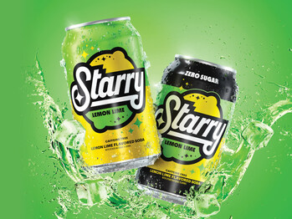
Starry, Pepsi’s newest lemon-lime soda, aims to take on chief rival Coca-Cola’s Sprite, which has dominated the market for decades and dwarfed Pepsi’s previous citrus drink Sierra Mist.
Though Pepsi has tried and failed to replace Sierra Mist in the past, they remain optimistic about Starry, due to its presentation as “bright, optimistic, and rooted in culture and fun,” according to a PepsiCo statement. With Pepsi banking on its name and marketing towards Gen-Z, is this newest drink catchy enough to land among the stars?

Astral Associations
Though only time will tell whether Starry will make a dent in Sprite’s huge market share, the name works overall and may catch on with consumers.
The name Starry creatively evokes thoughts of a spritzy, refreshing soda. One pictures the pleasant feeling of a starry night; its twinkling stars shining brightly overhead. In the context of a lemon—lime soda, this brightness is associated with citrus, acidity, and freshness; like how adding lime to a taco “brightens” up the flavor and enhances the experience.
We also can’t help but think of Van Gogh’s The Starry Night, iconic for its beauty, creativity, and swirly texture which gives the appearance of motion.
As far as names which borrow from the night sky, Starry is a fairly good choice, being simple and on target. The concise name particularly puts the focus on stars themselves, with the four-point star embedded in the wordmark’s “S” further reinforcing this mindful association. A similar name like Superstar or Shooting Star runs the risk of suggesting the ideas of fame and excellence which a five—pointed star evokes (think of a five—star review, for example).
Though we don’t take logo execution into account when grading names, we give Starry props for its angled font and underscore, which reinforce a theme of energy, positivity, and forward motion.

Sizing up to Sprite
The name Starry carries meaning in the soda industry as well. While its one-word name beginning with “S” doesn’t serve to deviate from Sprite, a name which also evokes brightness and energy, the name Starry does come with some upsides.
Starting with the letter “S” subtly places Starry in the caffeine-free lemon-lime niche, following the convention of other major brands like SevenUp, Sprite, and Sierra Mist. The “S” sound itself phonetically symbolizes speed and smoothness.
Additionally, Starry’s one-word name does a much better job of contrasting with Mountain Dew, the citrus soda with the greatest market share, than Sierra Mist did. Pepsi’s Sierra Mist really fell flat in this respect, being essentially a synonym of Mountain Dew (an especially odd choice considering the distinctly different taste and much higher caffeine content of the latter).
We also don’t love that the name suggests a night-time beverage, which could imply anything from a sleep aid to an alcoholic party drink. To be fair, however, Pepsi seems to have accounted for this perception in their branding, choosing to use bright shades of yellow and green.
Speaking of design, although the logo reinforces some of the messaging as noted above, it doesn’t work very hard to convey twinkly zest and refreshing fun. Its heavy colors and shapes come across as very old-school or retro (Think “Dynamite” or a similar 50s, 60s, or 70s comic book). Looking back at Pepsi’s statement, this particular aesthetic may have been an intentional choice, given that some trend watchers say Gen Z loves everything retro.
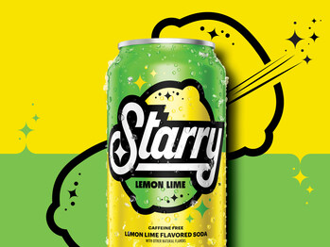
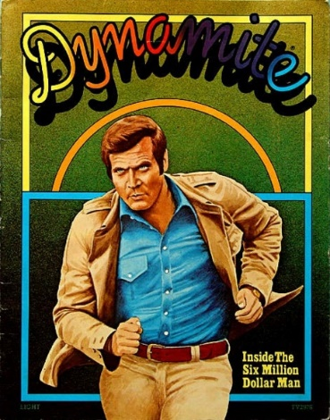

Final Verdict
While its name evokes pleasant and energetic feelings, when you take away the branding and stylized design, Starry is not a particularly creative or descriptive name. Though it sounds distinct from competitor Mountain Dew, we don’t think the name is far enough from Sprite to really carve out its own identity. While we can’t speak for its future commercial success, we can confidently slap a modest B— on Starry.

